**SRS FOR APPLICATION FOR GROCERY DELIVERY**

BY

M AARTHY

Y GRACINA SHYRINE

D POOJA

3RD YEAR

PANIMALAR INSTITUTE OF TECHNOLOGY

**TABLE OF CONTENTS**

**1. INTRODUCTION**

1.1. Scope

1.2. Objective

1.3. Advantages

1.4. Tools

**2. OVERALL DESCRIPTION**

2.1. Product Perspective

2.2. Product Feature

2.3. User Characteristics

2.4. Functional Requirement

*2.4.1. Sign up*

*2.4.2. Search*

*2.4.3. Order Placement*

*2.4.4. Product/ Store Review*

*2.4.5 Payment*

*2.4.6 App Review*

2.5 Non-Functional Requirement

**3. DIAGRAM**

3.1. Use Case Diagram

3.2. Class Diagram

3.3. State Diagram

3.4. Sequence Diagram

3.5. Data flow Diagram

**4. Reference**

**1. INTRODUCTION:**

The Grocery app is a software application designed to enable users to purchase groceries online and have them delivered to their doorstep. Nowadays everyone prefers online shopping to visit stores. And for groceries, people prefer fresh and new items to be delivered to their tables with good care and hygiene. The purpose of this delivery app is to provide a convenient and user-friendly platform for customers to purchase groceries from the comfort of their homes, while also enabling grocery stores to expand their customer base and increase their sales revenue.

1.1 Scope:

The Online Grocery market is to increase the profit margin of business owners and conveniently grant access to products available in the supermarket to potential customers.

The scope of the Grocery App includes a range of features such as product browsing, shopping cart, checkout, payment gateway integration, delivery options, store locator, ratings, and reviews.

1.2 Objective:

The primary objective of the project is to deliver a high-quality and reliable application that meets the needs and expectations of our users while also providing a competitive advantage to grocery stores.

The app offers features that incentivize customers to shop frequently and return to the app, such as personalized recommendations, loyalty programs, and exclusive discounts.

1.3 Advantages:

This grocery shop will be an online shop. This makes it possible for anyone to access it anywhere in the world. Below are some benefits of this,

• Incredible convenience.

• Price comparisons are made possible.

• It comes with an infinite choice for customers to see the best product available.

• Customer reviews are made relevant and leave comments for other shoppers to read for a better shopping experience.

1.4 Tools:

SOFTWARE:

The application tools used for the development of the website are,

* JAVA
* MySQL
* Paypal
* Photoshop
* Google Maps

HARDWARE:

* Android version 2.3 gingerbread (minimum, android users)
* 2GB ram
* 1.2 GHz processor
* Intel i5
* Windows 7/8/8.1/10

**2. OVERALL DESCRIPTION:**

2.1 Product Perspective:

The software described in this SRS is the software for a complete Online Grocery Delivery System. The system merges various hardware and software elements and further interfaces with external systems. It relies on a number of external interfaces for persistence and unhandled tasks, as well as physically interfacing with humans.

2.2 Product Features:

The features of the proposed system include,

* Customer Account registration.
* Products and pricing display.
* Customer relation is possible.
* Draw the supermarkets closer to customers.
* It never closes down.
* On-time delivery capability.

2.3 User Characteristics:

Users should be familiar with the terms like login, register, order system, etc.

The language proficiency of the users will impact the language options available within the system.

Users may have different payment preferences, such as credit card, debit card, or cash on delivery.

Users with mobility issues may require special accommodations, such as the ability to schedule deliveries at specific times or have groceries delivered directly to their kitchen.

2.4 Functional Requirement:

*2.4.1 Sign up*

Input: The user has to register either using a mobile number or email.

Output: Confirmation of registration status through OTP verification.

*2.4.2 Search*

Input: Enter the name of the product or the store from where you want the product.

Output: A list of products and stores related to the keyword appears.

*2.4.3 Order placement*

Select the product: Once the store from where a product needed is selected, browse through the product list and add items to your cart by clicking on them.

Confirm your order: Once you have added all the items you want, review it to ensure it is correct and complete.

*2.4.4 Product/Store Review*

A review on the selected product or the store will be available below that product.

Before payment, customers can go through those reviews and compare the selected item with other items.

*2.4.5 Payment*

It asks the customer to enter the various credit card details of the person buying a product.

1. Credit card type

2. Credit card number

3. CVC number of the card

4. Expiration date of the card

5. The name on the card

*2.4.6 App Review*

After payment, the review option will be shown at the bottom of the screen.

Customers can feel free to share their opinion about the process.

Select a star rating that reflects the overall experience with the app.

The app allows written reviews, where customers can write a few sentences about their experience with the app. Specific details could be helpful to other users, such as the speed of delivery or the quality of the food.

2.5 Non-Functional Characteristic:

Following Non-Functional Requirements will be there in the insurance to the internet:

1. Secure access to consumers’ confidential data.
2. 24X7 availability.
3. Better component design to get better performance at peak time.
4. Flexible service-based architecture will be highly desirable for future extension.

Various other Non-Functional Requirements are:

* Security
* Reliability
* Maintainability
* Portability
* Extensibility
* Reusability
* Compatibility
* Resource Utilization

**3. DIAGRAM:**

3.1 Use Case Diagram:

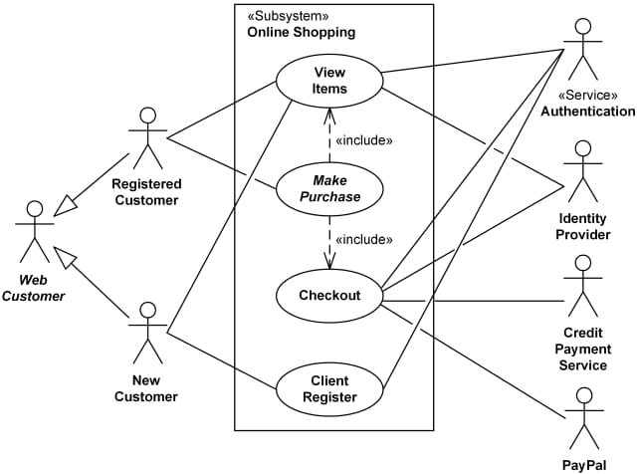

3.2 Class Diagram:

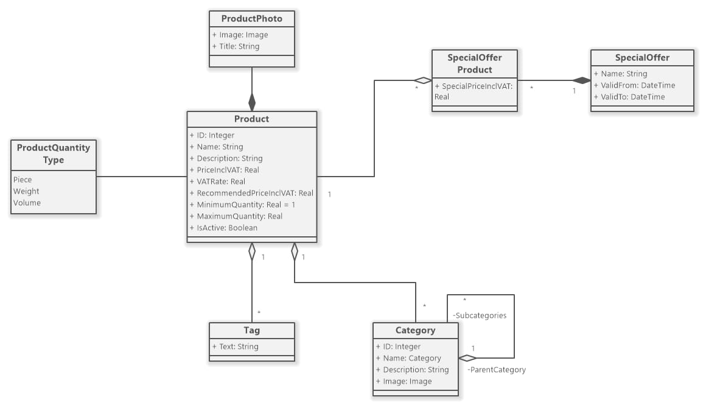

3.3 State Diagram:

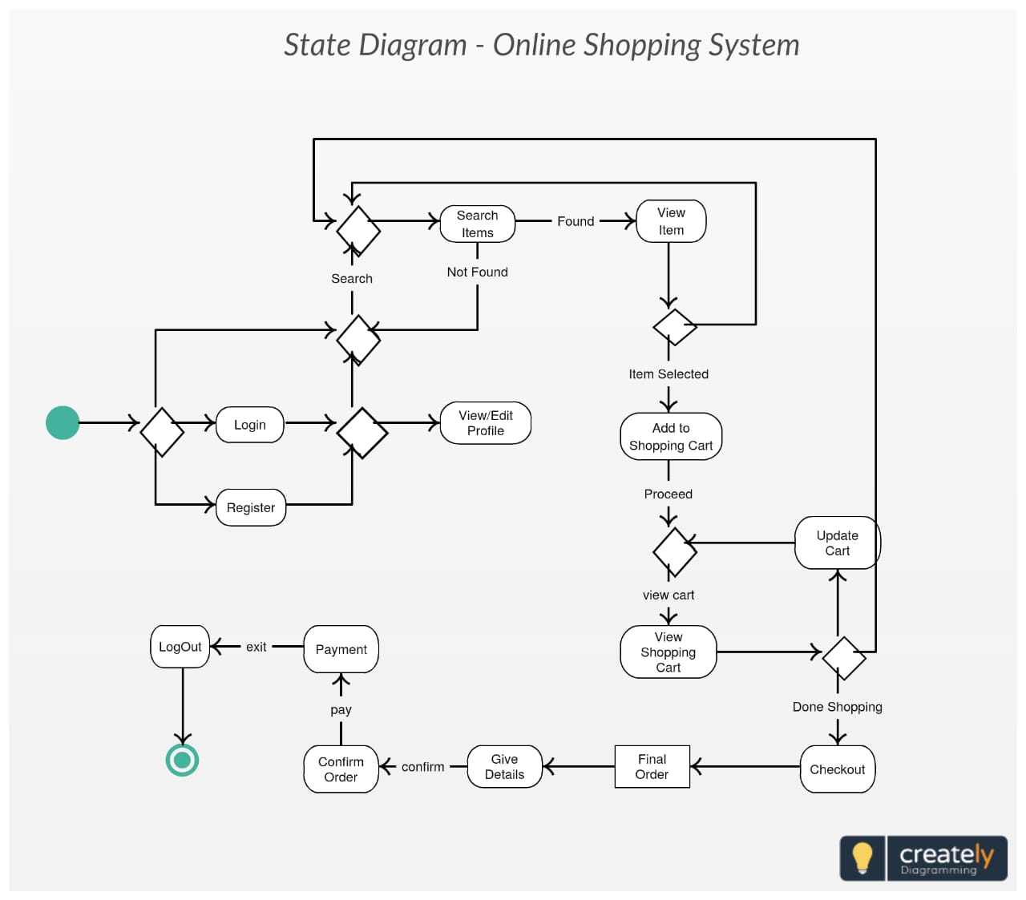

3.4 Sequence Diagram:

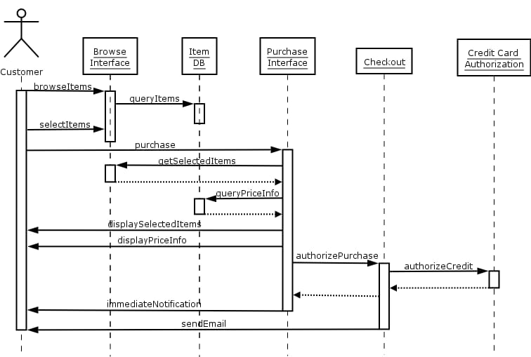

3.5 Data Flow Diagram:

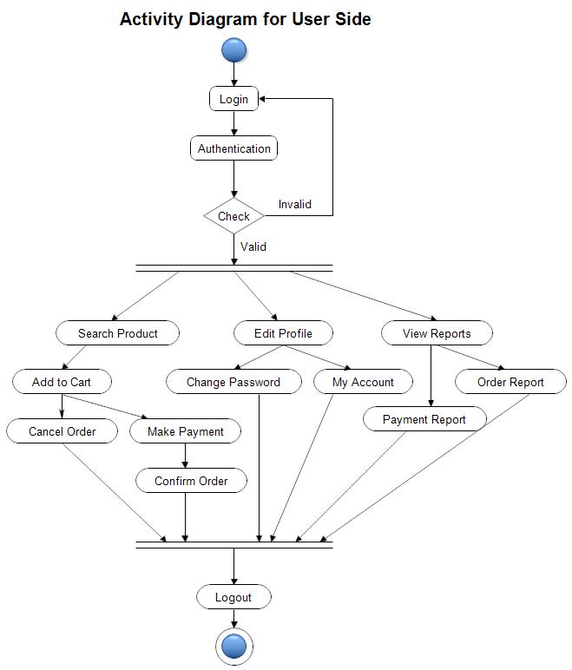

**4. References:**

Google, ChatGpt, SRS Reference Papers.